How Inkjet Printers Work

Process
After processing the page, the inkjet printer ensures the printheads are clean. Then, the paper feed stepper motor is activated which engages the rollers and feeds a sheet of paper into the printer. After the paper is fed into the printer, the print head stepper motor uses the belt to move the print head assembly across the page. Each time the print head sprays dots of ink on the page, the motor pauses for a fraction of a second then moves a tiny bit. At each stop, multiple dots are made with a precise combination of CMYK colors. At the end of a complete pass, the paper feed stepper motor advances the paper a fraction of an inch. This process continues until the page is printed. After completion, the print head is parked, and the paper feed stepper motor spins the rollers to finish pushing the completed page into the output tray.

Ink Cartridge/Toner
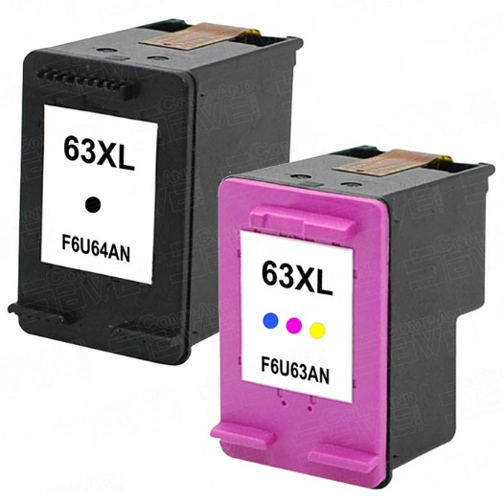
Inkjet printers use ink cartridges in their printers. They contain a liquid ink that is used for printing on the page. The printhead in an inkjet printer is contained inside the cartridge itself. In a thermal bubble inkjet printer, they print their pages by using tiny resistors to create heat. This causes the ink to vaporize and create a bubble. As it expands, some of the ink is pushed out of a nozzle onto the paper. When the bubble collapses, a vacuum is created and pulls more ink into the printhead from the cartridge. This results in the ink being projected onto the paper. In a piezoelectric inkjet printer, they use piezo crystals. A crystal is located at the back of the ink reservoir of each nozzle. The crystal receives a tiny electric charge that causes a vibration. When it vibrates inward, it forces a tiny amount of ink out of the nozzle. When it vibrates out, it pulls more ink into the reservoir to replace the ink sprayed out.
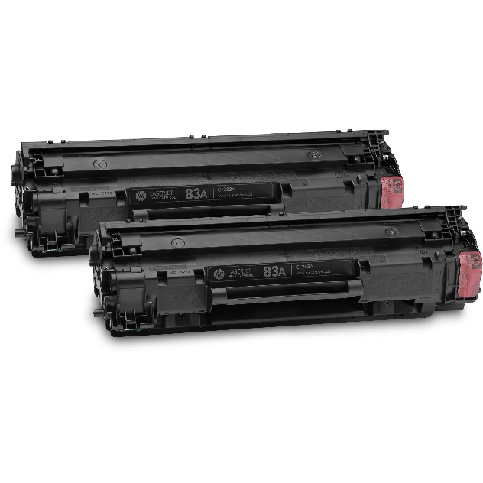
Laser printers use toner cartridges in their printers. They contain a toner powder made of plastic and carbon particles that are used for printing on the page. Laser printers print their pages by using a laser. A laser inside the printer “draws” an image onto the imaging drum by neutralizing a negative charge. Then, when a positively charged paper rolls through the drum, the toner gets attracted to the paper. Then, the process is finished when the fuser unit fuses the toner and paper together.

