Thermal and Impact Printers

Thermal Printers
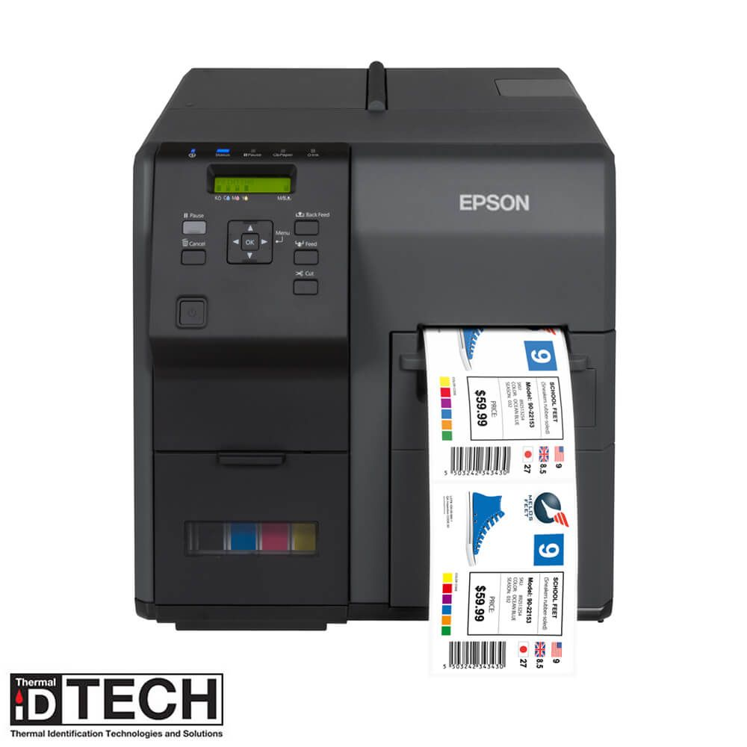
Thermal printers work by applying color through heating a special ribbon coated with a wax-like material. The heat melts the wax which is then sealed to the surface of the paper by Teflon coated rollers. In the heating unit, it consists of an array of small heaters that melt wax in small dots. These dots represent data sent from the computer to the printer. The paper runs through this process four different times, each time a new color added to the paper. These use the CMYK color combination (cyan, magenta, yellow, and black). Color thermal printers are used for high quality presentation drawings and illustrations, and corporations use them for special applications. However, they are not typically used in a home setting due to having a high cost per sheet. These printers are typically used for their high quality. Other than these uses, they can also be used to make labels, safety signs, wayfinding markers, barcodes, shipping labels, and other heavily-used items. The print head needs to be cleaned often, which is delicate and sensitive. The ribbon and media also need to be replaced often, as these are the materials used for prints.
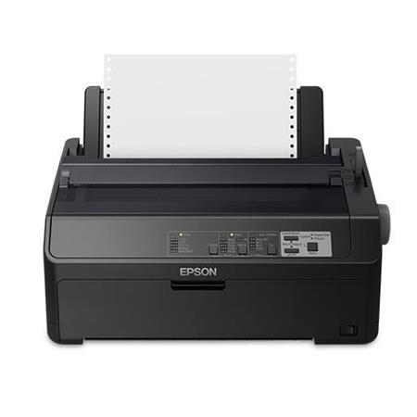
Impact Printers
Impact printers, or dot matrix printers, use very small dots to print text and images. The print head consists of a line of small metal rods: print pins. An electrical coil, solenoid, controls each print pin and creates a magnetic field when energized. The print pin is constructed with a magnet at one end, which is attracted to the coil when the solenoid is energized, causing the print pin to rapidly move forward and strike an ink ribbon. Each energized solenoid causes that individual print to strike the ribbon, leaving a dot of ink on the paper. Normally, the print heads are durable and last a long time if the printer is kept clean. The print head will need to be replaced if a pin is jammed. Additionally, the paper and ink ribbon will need to be replaced often.

Impact vs. Daisy Chain Printers
Daisy chain printers are restricted to a limited character set due to their nature (can only fit up to 96 glyphs) and is pre-formed. Dot-based printers are not limited to this finite character set due to how they work and can print any character or graphic.

